**INTEGRATION TEST REPORT**

**main_menu -> Add bidder details**

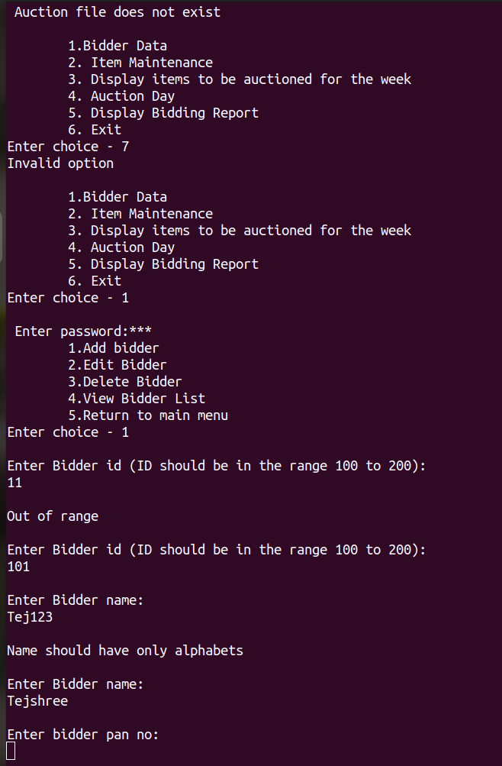

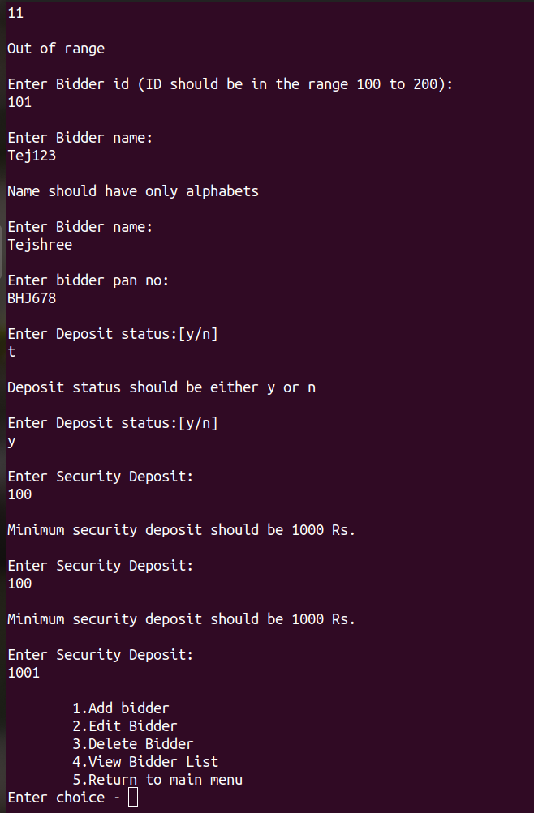

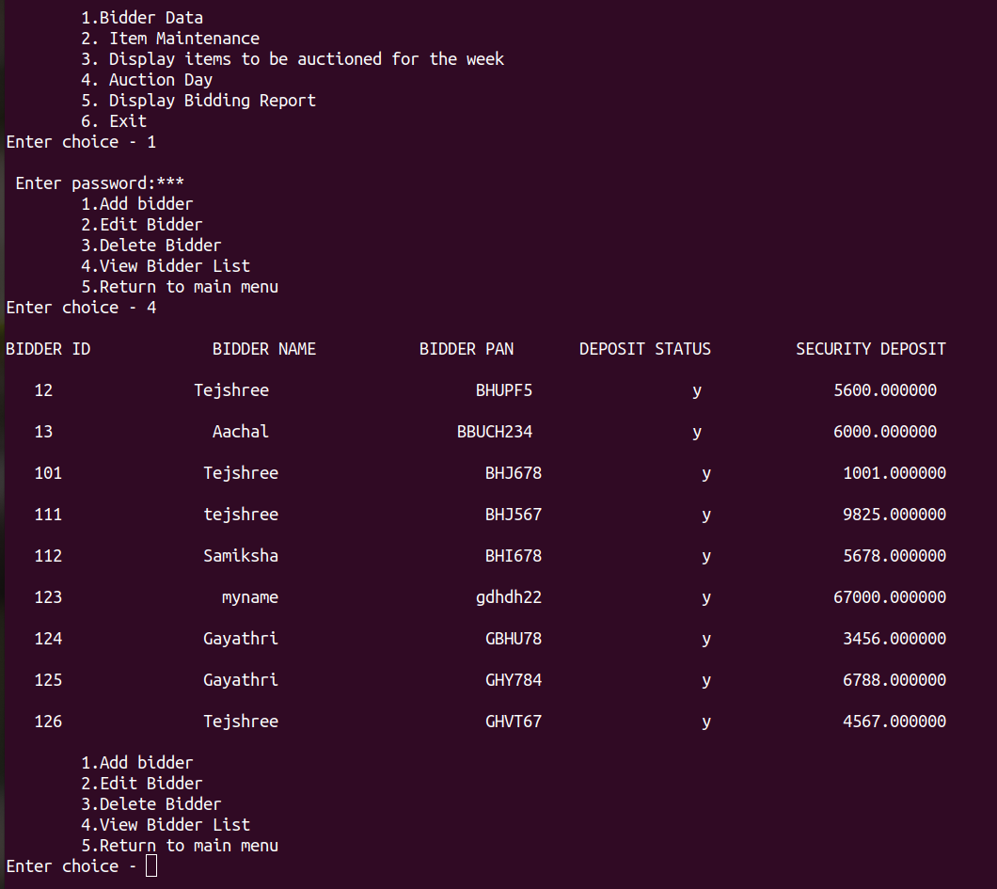

.**main_menu -> Add bidder details**

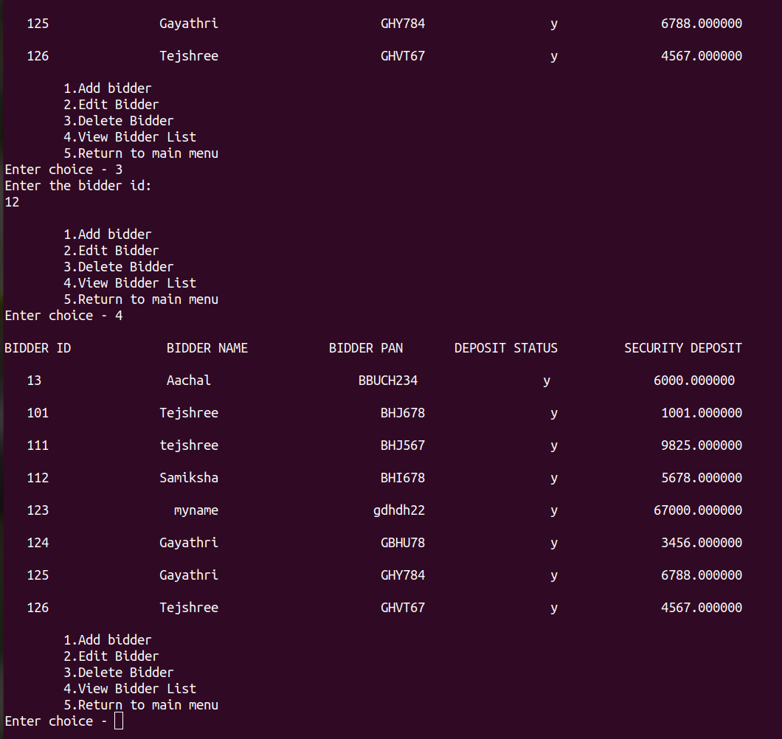**main_menu -> Delete and view bidder details**